# ICT SBA

5A Jennifer Ko (10)

# Table Of Content:

## [Introduction](#_Introduction:)------------------------------------------P.3

## Web Page description------------------------------P.4

### [Home Page](#_Home Page)-----------------------------P.4-P.8

### [Shopping Cart Page](#_Shopping Cart Page)-----------------P.9-P.10

### [“Most Populated”& “Recommended” Page](#_\“Most Populated\”& \“Recommended Page\”)

---------------------------------------------------------P.11

* **[About Us Page](#_About Us Page)**-----------------------------P.12
* **[Forgot Password Page](#_Forgot Password Page)**-------------------P.13
* **[Sign Up Page](#_Sign Up page)**-------------------------P.14-P.15

# Introduction:

### Online Book Store

To set up a website for selling books over the internet.We should design the shopping cart layout for customers to place order.Customers click the book cover to view more details of the book.Customers can enter the quantity needed in textbox and click “Check Out” to finish the order.Or they can save the selections in the shopping cart and continue surfing.

Other than the shopping cart layout.We should create a prototype for the online book store and other pages should be added to demonstrate service of online book store with enhancing the friendliness of web page.

# Web Page description:

## Home Page

[1](#one)

# 

[2](#two)

[4](#four)

[3](#three)

[5](#five)

[7](#seven)

[6](#six)

Upper part of home page

1. The icon in the web title is the icon of book,it can more attract customers.
2. The header with the name of book store.It will always keep on the uppermost of the page.
3. The scrolling text which will show the most updated information of sales and used the color yellow to attract customers.
4. Search bar,user can enter the book name or author name in the search bar to search books,it can be more convenient to customers find their books.
5. Log in column:User can enter their “Username” and “Password” to log in and continue the process of “[Add to cart](#addtocart)” and “buy books”.Also,the log in column will check whether the user is a robot or not by clicking the check box-“I am not a robot”.In addition,it provide the function of “[Forgot password](#_Forgot Password Page)” and “[Sign up](#_Sign Up page)”.

Moreover,it will show welcoming message if the login “username” match with the “password”.

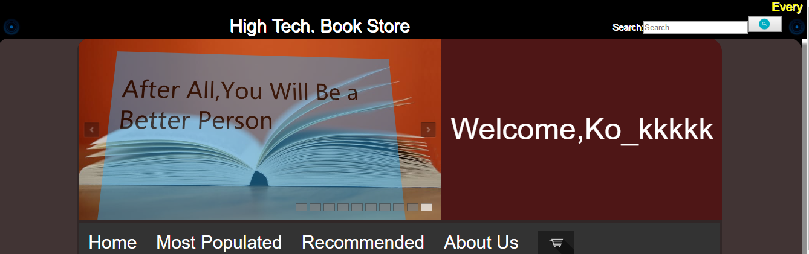

If the “username” or “password” is empty,the system will show the warning message.

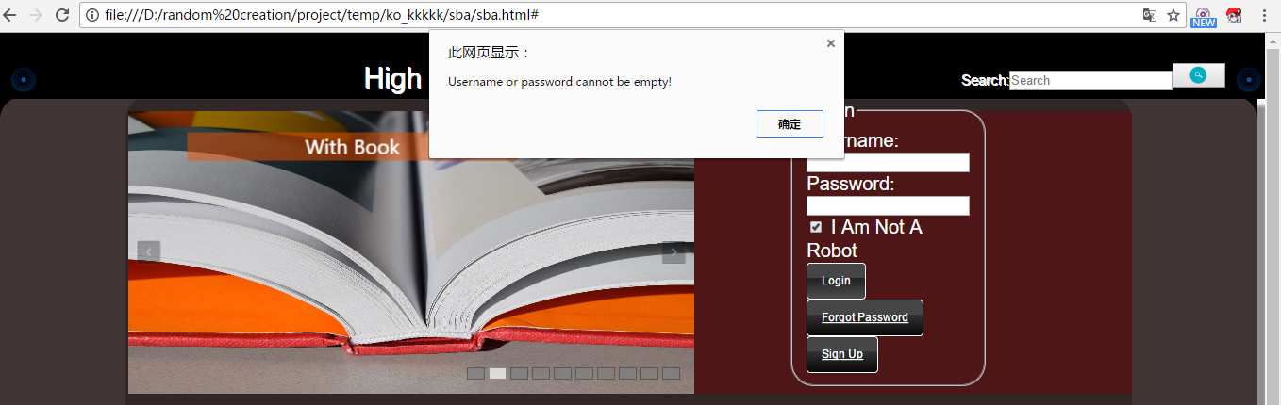

It will also have warning message if the “password” do not match with the “username”

1. Navigation bar: It will navigate users to different pages including the “Home”, “[Most Populated](#_\“Most Populated\”& \“Recommended\” Page_1)”, “[Recommend](#_\“Most Populated\”& \“Recommended\” Page_1)” , “[About Us](#_About Us Page)” and the icon of shopping cart.It will scroll together when the customers scroll down the page.It can make customers more convenient to different pages.

If the users click on the icon of shopping cart and with log in already,it will turn to the page of “[shopping cart](#_Shopping Cart Page)”.However,if the users clicked without log in,it will show the warning message to remind users to log in.

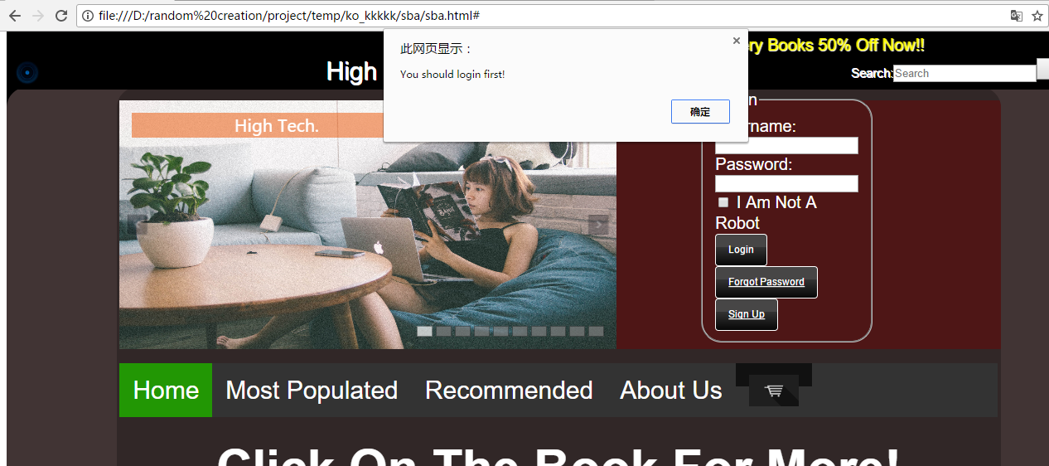

Also,it will show the numbers of books that that the users have add to

Cart.



1. Slide Show: It will show the promotion information of the book store with sliding effect automatically and can attract customer efficiently.

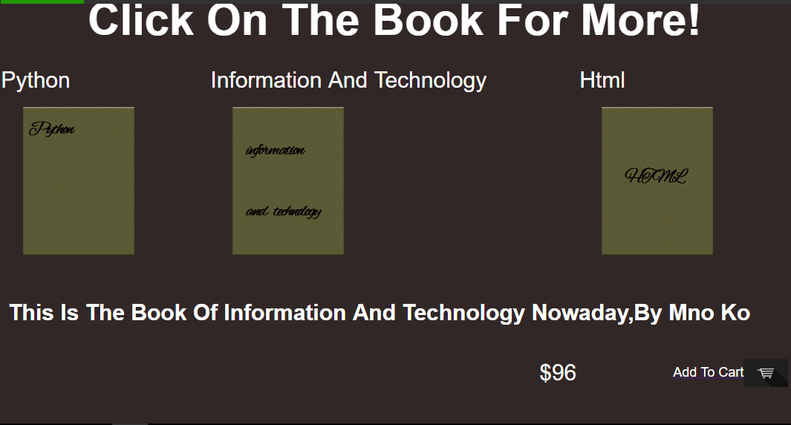

[8](#eight)

[9](#nine)

[10](#addtocart)

Middle part of home page

1. Show the information of books such as title and cover randomly,which can attract different type of customers with different books.
2. Description of books.It will be show the description and the price of the books when users click on the books’ cover.
3. “Add to cart” function.Customers can click the button to add the book to shopping cart.If the users do not log in,it will show the warning messages to remind users to log in.

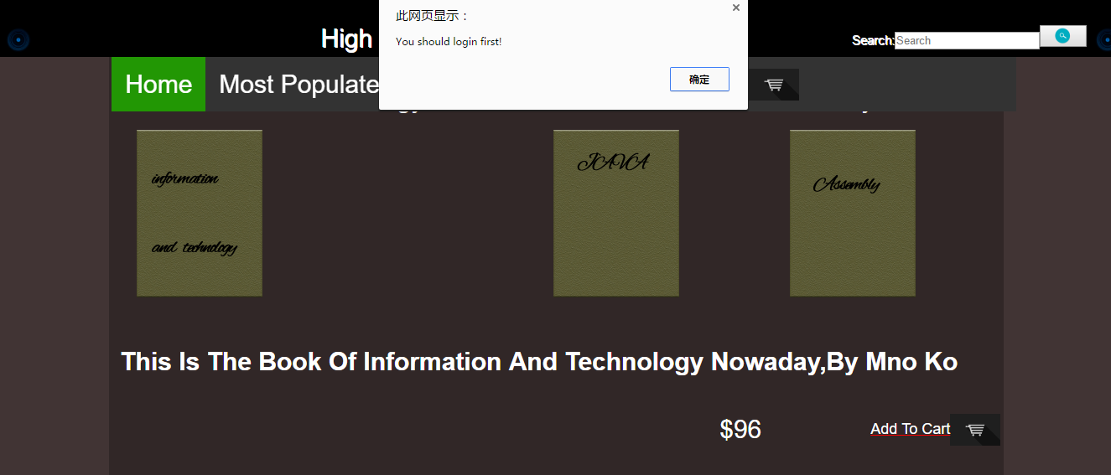

If the users select the same books again,it will show warning message to remind the user.

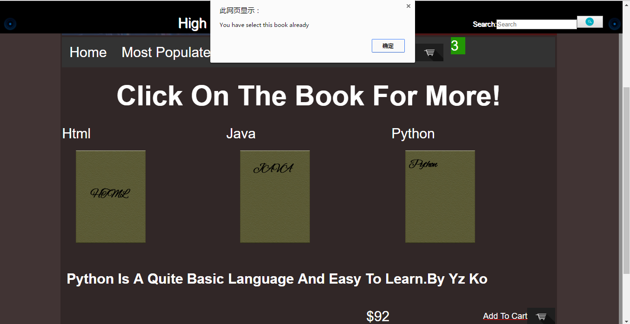

[11](#footer)



lower part of home page

1. Footer.With rounded angle,shadow and promotional sentence.

## Shopping Cart Page

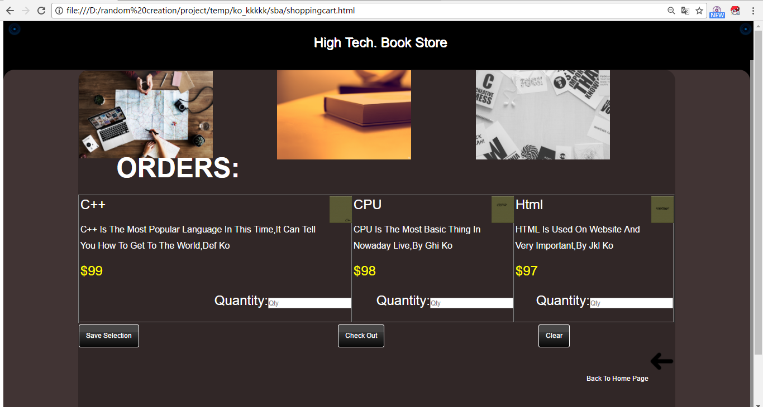

[1](#photo)

[2](#information)

[3](#checkout)

[4](#bsck)

Shopping Cart page

1. Photos about books,it is used for decoration and make users more comfortable to pay for the books.It can make customers more willing to pay.
2. The information of books.It will show the information such as the cover,title and description of the selected books that the users selected before.Also,the price of the books is marked with yellow color which can highlighted the price for customers.In addition,customers can enter the quantity of books in the text box.
3. There are 3 buttons for customers to click including the “Save Selection”, “Check Out” and “Clear”.

When users choose “Save Selection”,its selections and the quantity of books will be saved and back to home page for them to choose books continuously.A message will be showed during this process.It will be more convenient if users want to choose more books

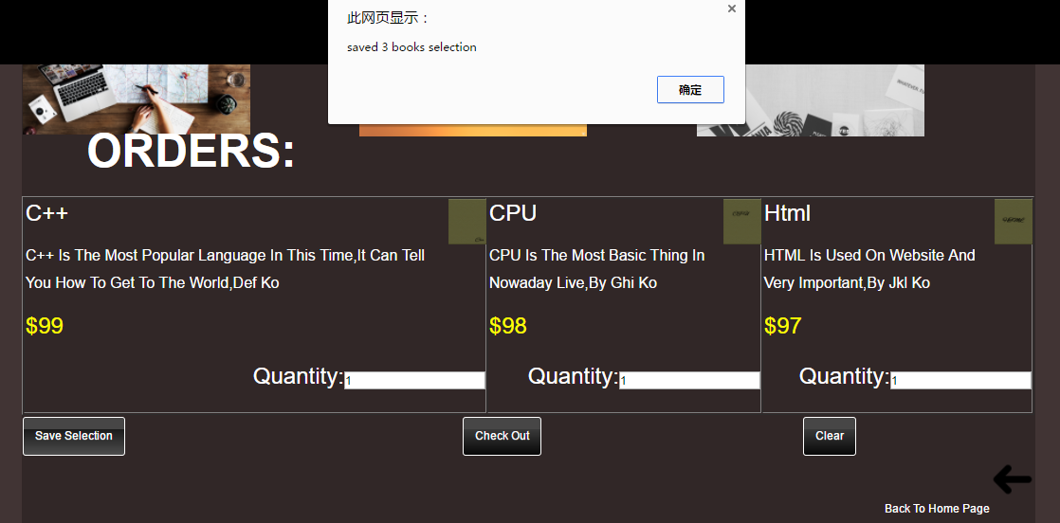

When users choose “Check Out”,it will calculate users’ total amount according to the quantity and the book type.And show a confirm message.

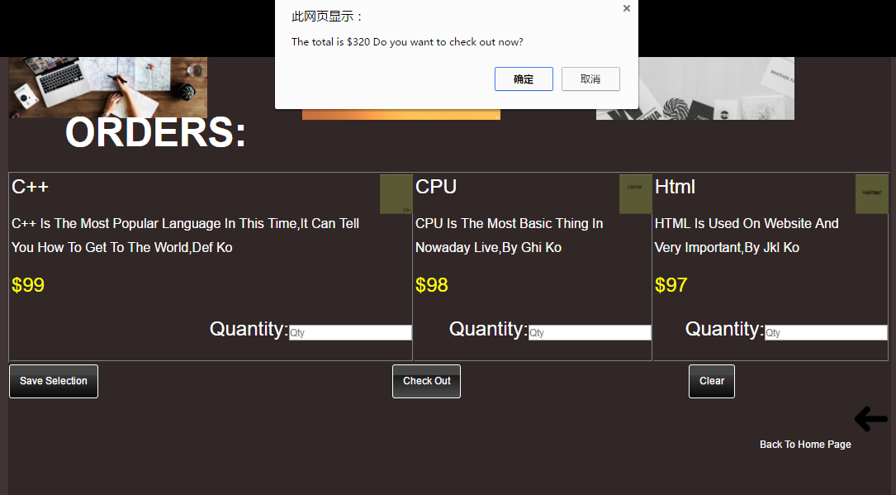

When users choose “Clear”,it will clear all the selection of user and direct them back to homepage.

1. Back to homepage button.It can direct customers back to homepage with an arrow button which is clear for customers to understand.

## “Most Populated”& “Recommended” Page

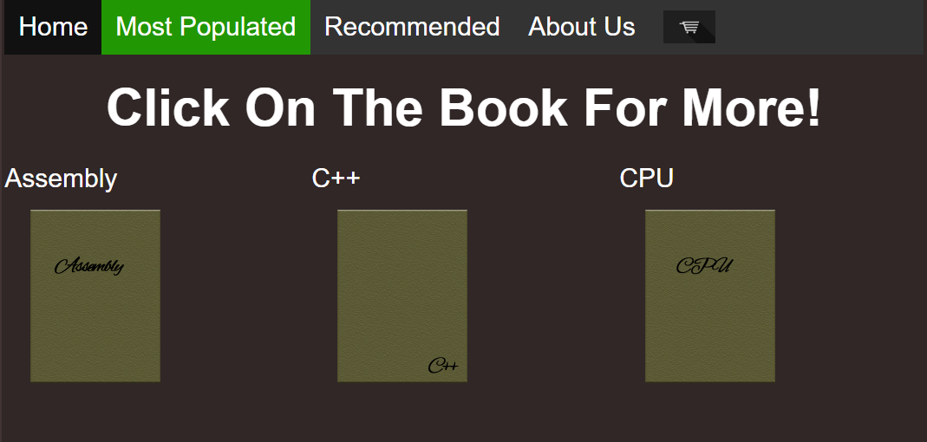

Most Populated page

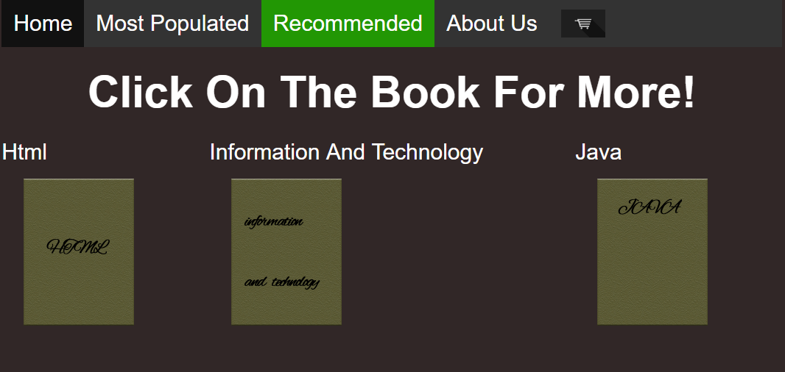

Recommended page

These two pages will show the most populated books and recommended books.These books are fixed which is different from the home page that random draw the books.Some books in these two pages can also be drawn by the home page which can attracted customers attention.

## About Us Page

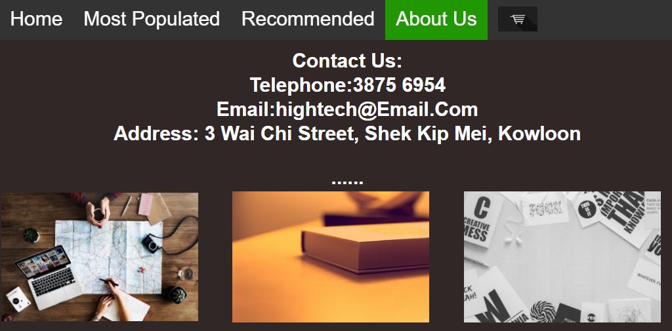

About Us page

In this page,it will provide the information of the book store including the telephone numbers,Email contact and the address.It also add some photos of the book store.User can not only know the information about the book store,they can also know the style of the book store.These photos can attract customers’ attention.

## Forgot Password Page

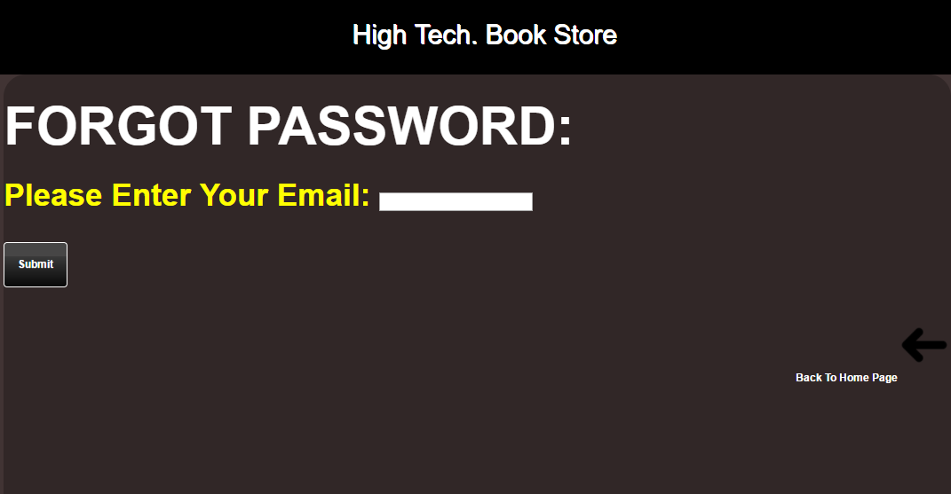

Forgot Password page

This page is for those users that forgot their password to find their password.User need to enter their registered email and click the button “Submit”. The system will then send an reset password email to their email.Also,users can click the “Back to Home Page” arrow to direct back to the home page.It will be convenient if the users wrongly click into this page.

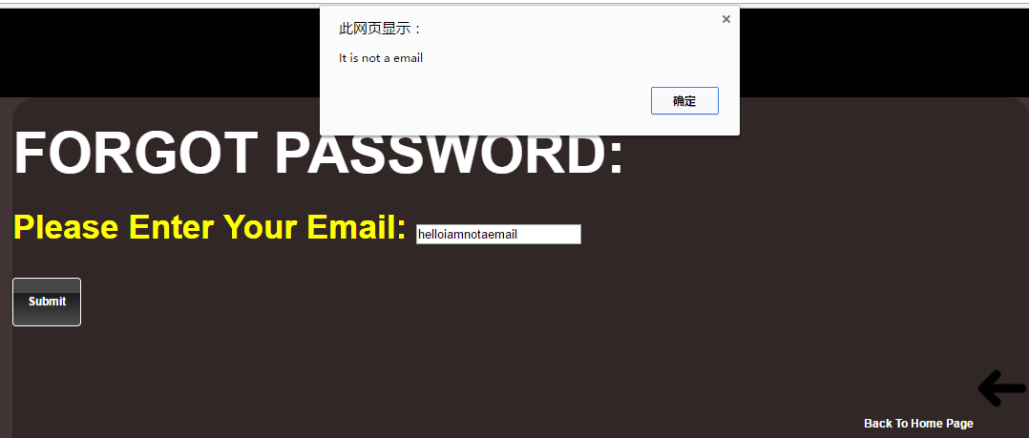In addition,it will have email validation when user click the “Submit” button.If the user do not type a valid email,it will show a warning message request the users to re-type the email.

## Sign Up page

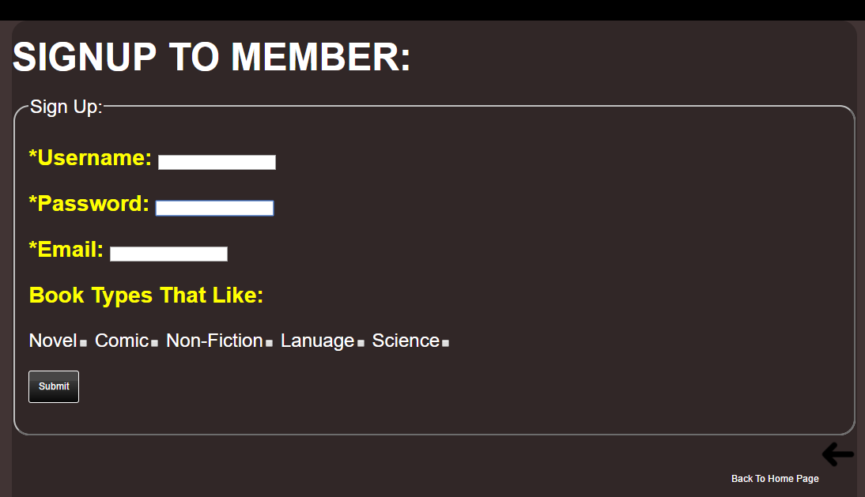

Forgot Password page

In this page,users must enter some basic information such as Username,Password and email to sign up to member. And user can choose whether to fill in the book types that they like in the check box.Then they can click the button “Submit” to finish the sign up.

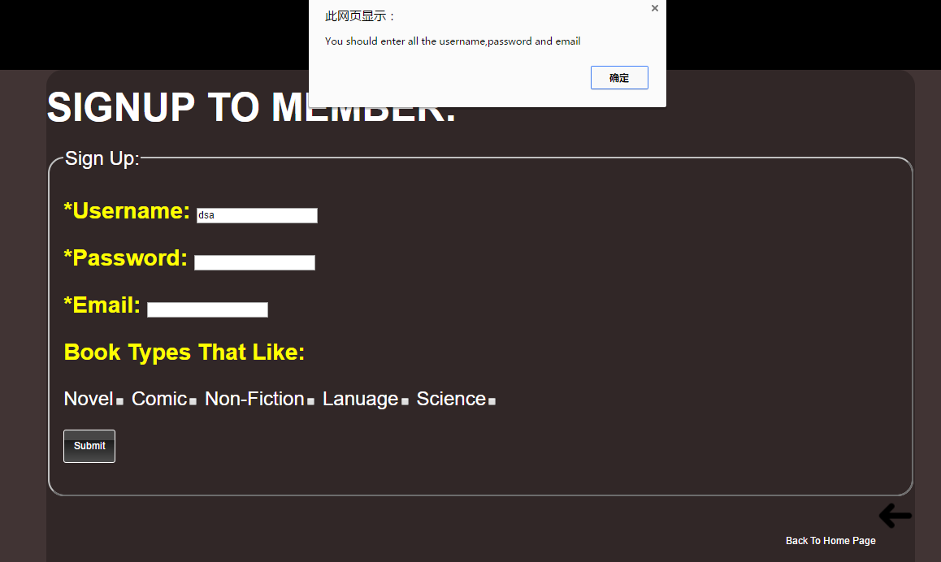If the users do not enter the basic information completely,the system will show warning message to remind them to fill in the information.

In addition, if the users do not enter a valid email,the system will show warning message too.It can remind the user to enter the email again.

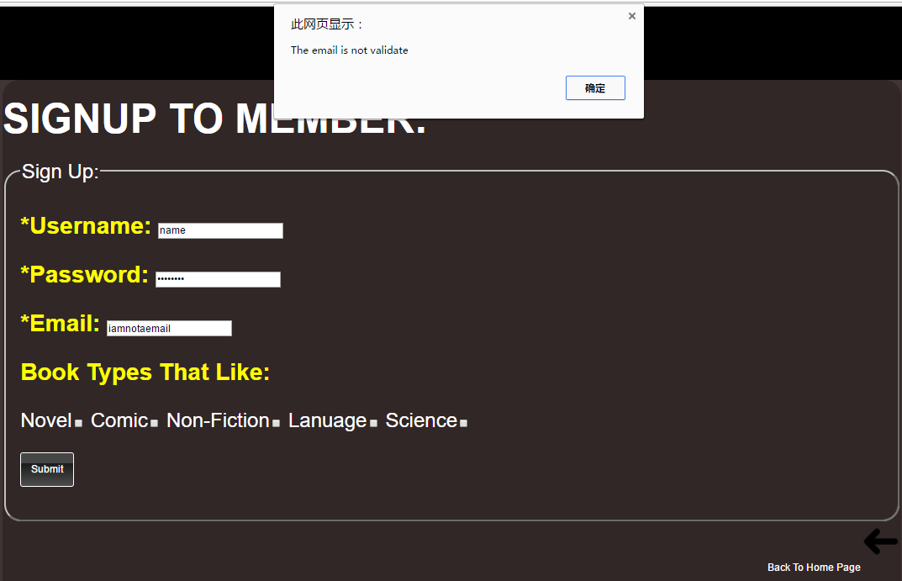

Also,users can click the “Back to Home Page” arrow to direct back to the home page.It will be convenient if the users wrongly click into this page.